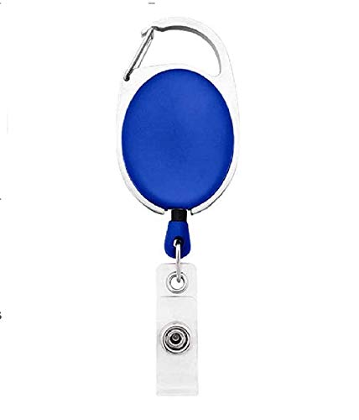

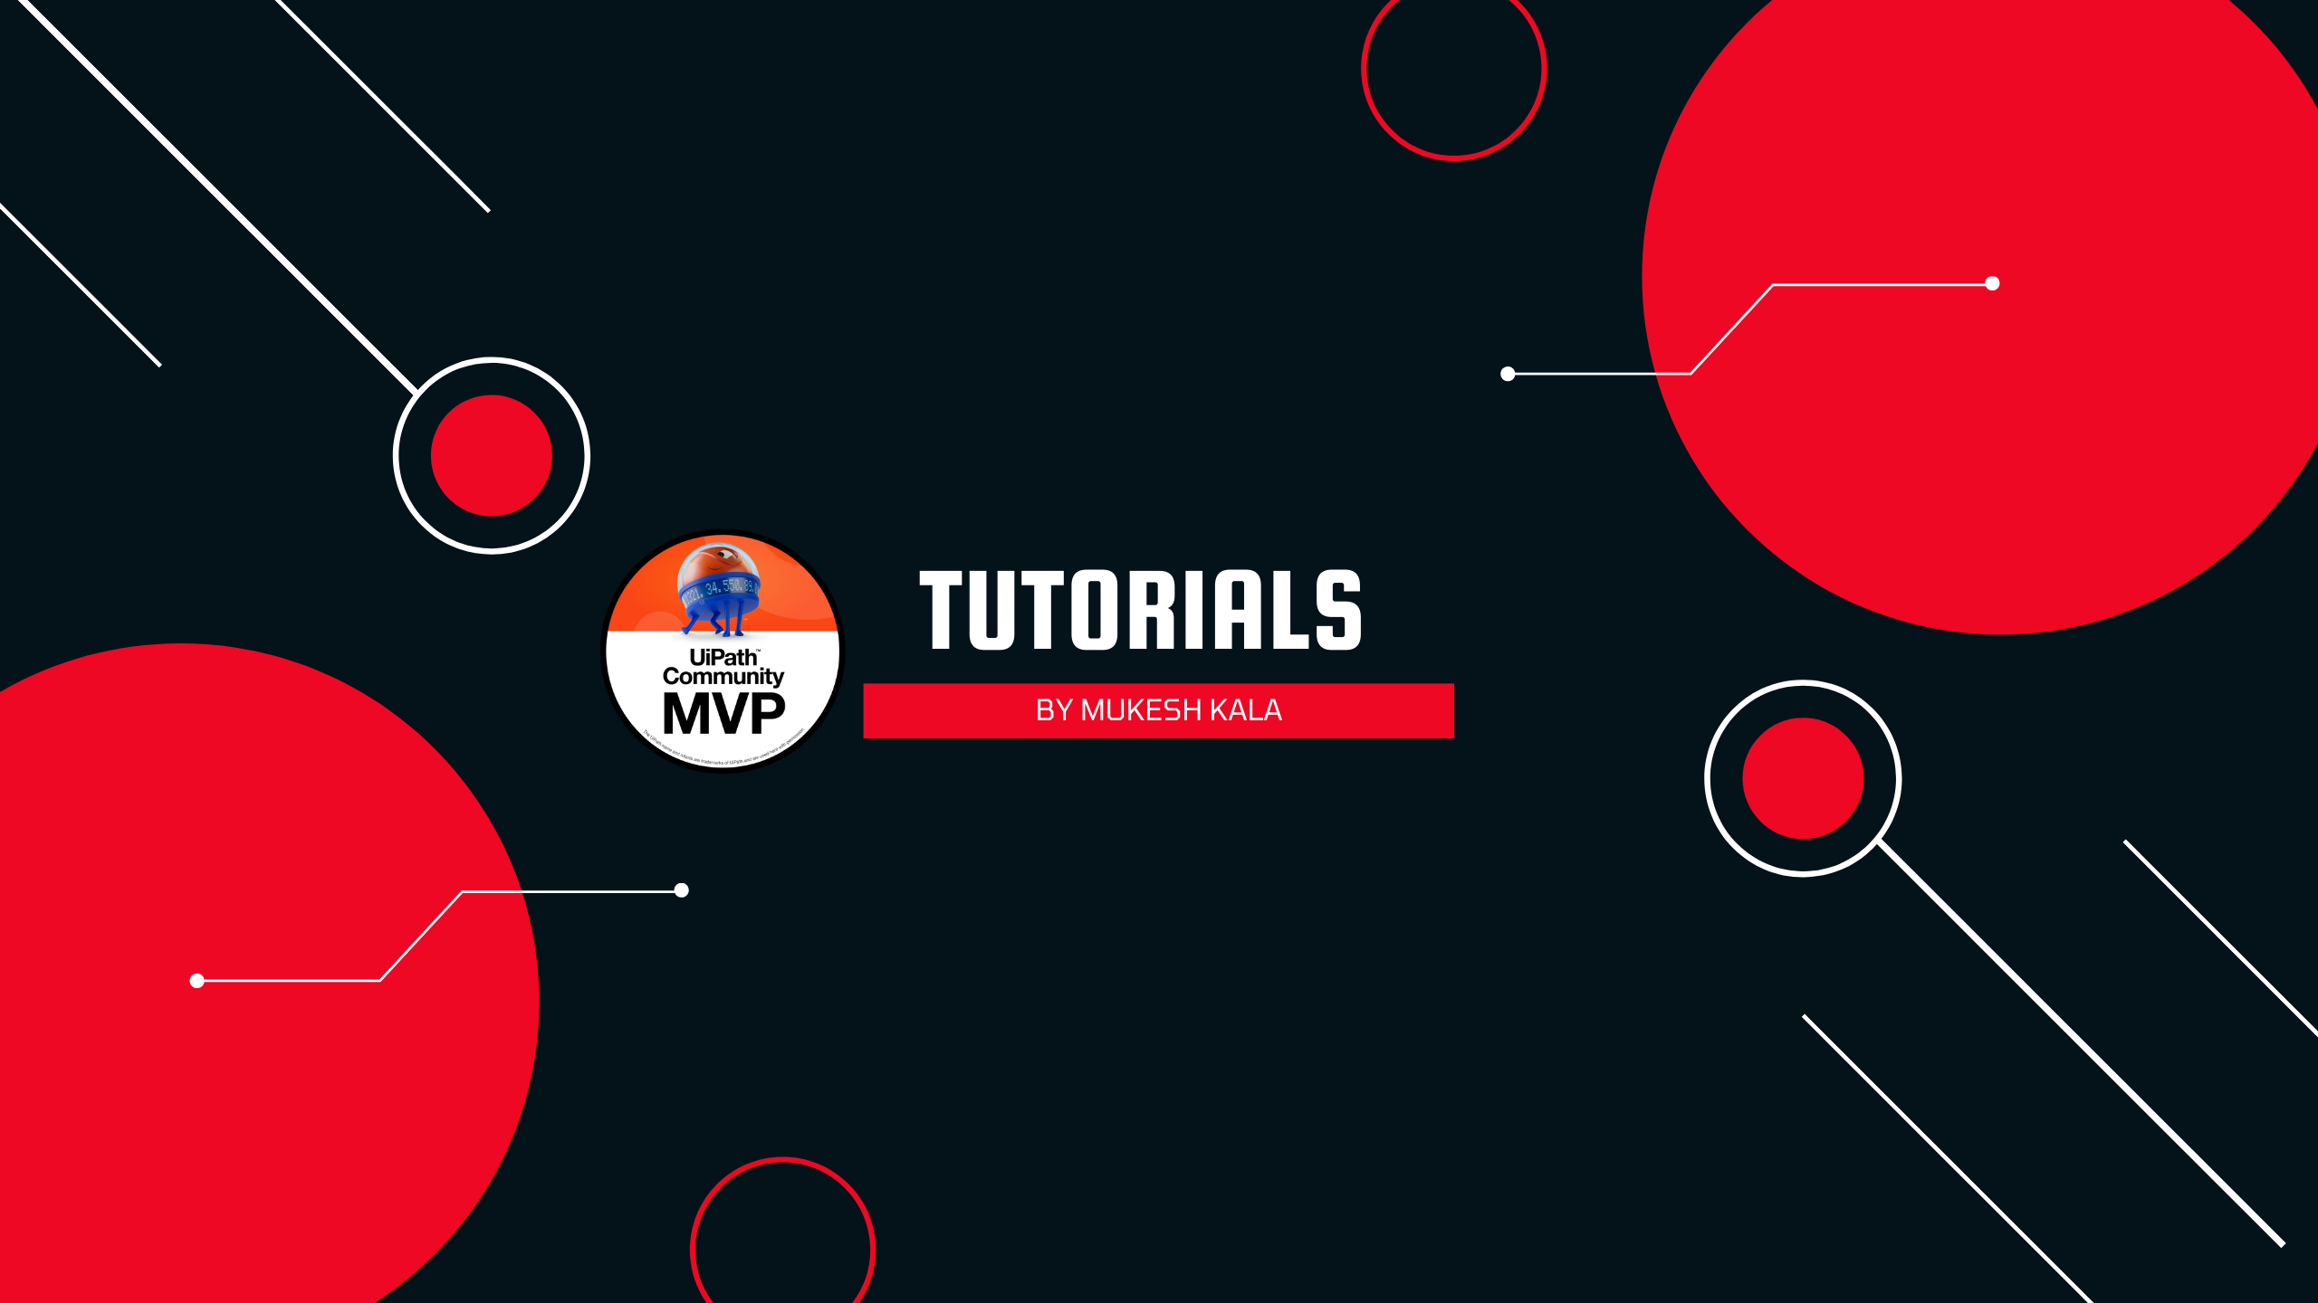

|  |  |
| --- | --- |
| **_Name** | PHOTO |
|  |
|  |
|  |
|  |

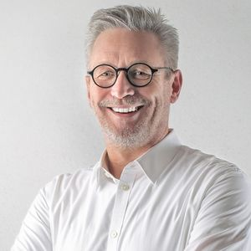

Questions / Queries – Drop an email to mailmukeshkala@gmail.com